Heritage University 09 -04-23
Mathematics and Computer Science Dept. Due: 09-10-23

C++ Programming
Homework 2
(control , loops)

1. . Find the value of e given a number.

#include <iostream>
using namespace std;
int main ()
{
int i,j,n;
double e, factorial;

cout << "Hello!" << endl
<< "Insert any number you would like to find the value of euler's number!" << endl
<< "(Please hit the return key after you insert the number)" << endl;
cin >> n;

for (i=1;i<n;i++)
{
(factorial = 1);

for (j=1;j<i;j++)
{
(factorial = factorial * j);
}

(e = e+1/factorial);
}

cout << "The value of e is " << e << "." << endl;
return 0;
}

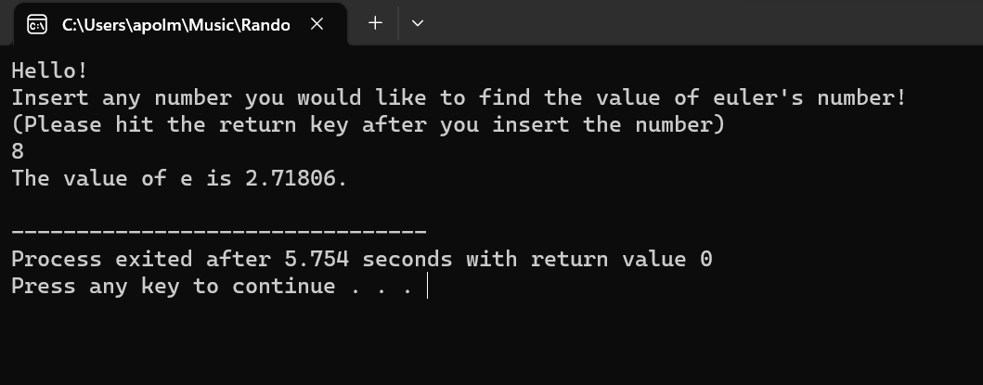

2. Modify your program from Programming Project 2 so that it calculates the retroactive salary for a worker for any number of months, instead of just six months. The number of months is entered by the user. Ch.2, proj. p106,#3

#include <iostream>
using namespace std;
int main ()
{
int placeholder;
double as, amount_months, m_to_year, rp, new_as, new_ms;
const double inc = 0.076;
char ans;

cout.setf(ios::fixed);
cout.setf(ios::showpoint);
cout.precision(2);

do
{
cout << "Hello!" << endl
<< "First enter your annual pay!" << endl
<< "(Please do not use any commas, and don't forget to hit the return key after you enter it) \n";
cin >> as;
cout << "Your annual pay is of right now is " << as << " dollars." << endl;
cout << endl
<< "Now enter the amount of months you will calculating retroactive pay!" << endl;
cin >> placeholder;
cout << "You wish to see the retroactive of " << placeholder << " months of your annual pay!\n"
<< endl;

(amount_months = placeholder);
(m_to_year = (amount_months/12));
(rp = (as*m_to_year) * inc);
cout << "Your retroactive pay is " << rp << " dollars." << endl;

(new_as = (rp + as));
cout << "Your new annual salary is " << new_as << " dollars." << endl;

(new_ms = (new_as/12));
cout << "Your new monthly salary is " << new_ms << " dollars." << endl;

cout << endl;
cout << "Would you like to do another calculation of a annual salary with a certain amount of months of retroactive pay that you decide?\n";
cout << "Press y for yes" << endl
<< "Press n for no" << endl;
cin >> ans;
cout << endl;
} while (ans == 'y' || ans == 'Y');

cout << "I hope you have an amazing rest of your day!\n";
return 0;
}

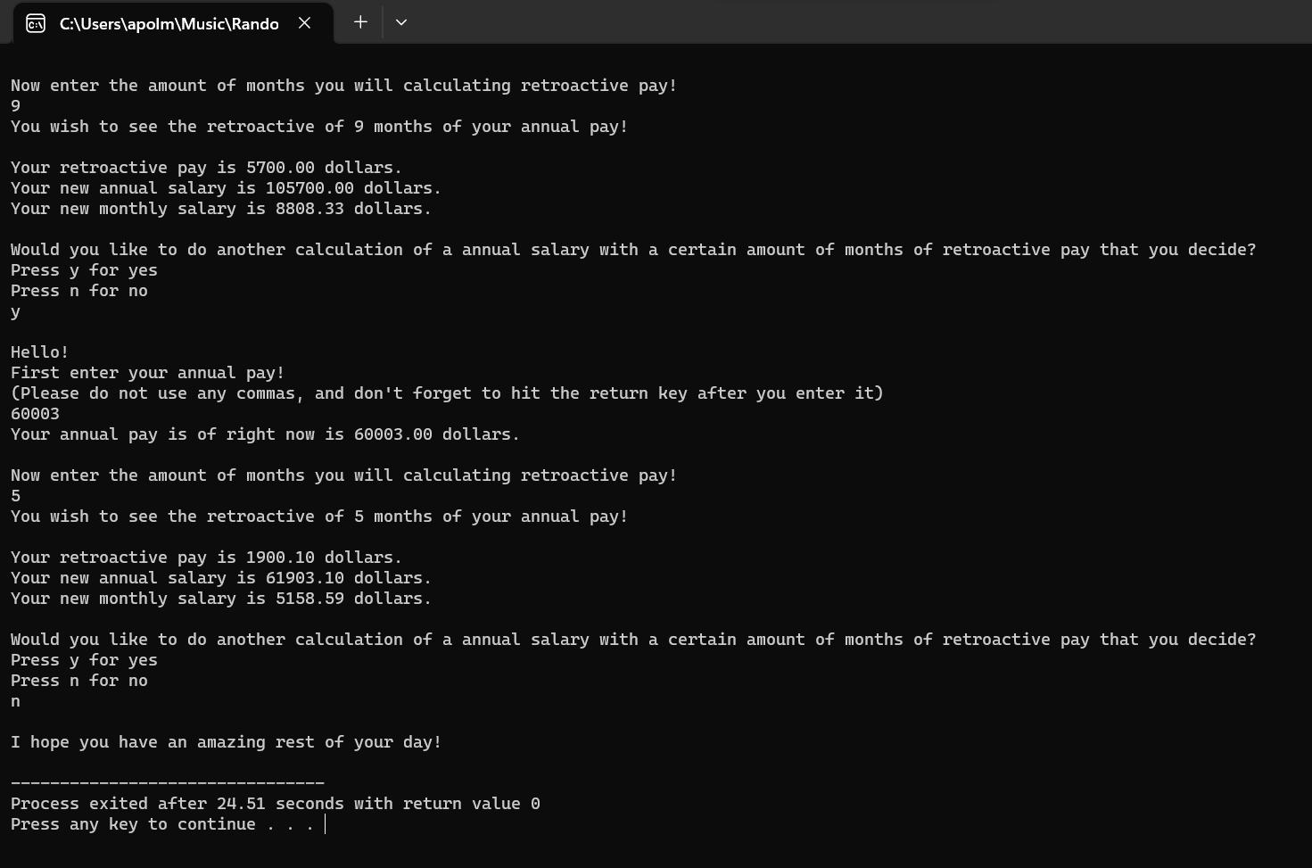

3. An employee is paid at a rate of $16.78 per hour for the first 40 hours worked in a week. Any hours over that are paid at the overtime rate of one and one half times that. From the worker’s gross pay, 6% is withheld for social security tax, 14% is withheld for federal income tax, 5% is withheld for state income tax, and $10 per week is withheld for union dues. If the worker has three or more dependents, then an additional $35 is withheld to cover the extra cost of health insurance beyond what the employer
pays. Write a program that will read in the number of hours worked in a week and the number of dependents as input, and will then output the worker’s gross pay, each withholding amount, and the net take-home pay for the week. For a harder version, write your program so that it allows the calculation to be repeated as often as the user wishes. If this is a class exercise, ask your instructor whether you should do this harder version.

#include <iostream>
using namespace std;
int main ()
{
int dependents;
double hours, sst, fit, sit, total_pay, temp_total, overtime, overtime_total;
const double b_overtime=40, wage=16.78, unionfees=-10, dep_fee=-35;
char ans;

cout.setf(ios::fixed);
cout.setf(ios::showpoint);
cout.precision(2);

do
{
cout << "Insert the amount of hours you worked this week:" << endl;
cin >> hours;
cout << "Insert the amount of dependents you have:" << endl;
cin >> dependents;

if (hours <= b_overtime)
{
(temp_total = hours * wage);
(total_pay = temp_total);
(sst = temp_total * 0.06);
(total_pay = total_pay - sst);
(fit = temp_total * 0.14);
(total_pay = total_pay - fit);
(sit = temp_total * 0.05);
(total_pay = total_pay - sit);
(total_pay = total_pay + unionfees);

if (dependents >= 3)
{
(total_pay = total_pay + dep_fee);
}
else if (dependents < 3)
{
(total_pay = total_pay);
}
else
{
cout << "The value you entered for dependents is invalid." << endl;
(total_pay = total_pay);
}
}
else if (hours > b_overtime)
{
(temp_total = b_overtime * wage);
(overtime = hours - b_overtime);
(overtime_total = wage *(overtime * 1.5));
(temp_total = overtime_total + temp_total);
(total_pay = temp_total);
(sst = temp_total * 0.06);
(total_pay = total_pay - sst);
(fit = temp_total * 0.14);
(total_pay = total_pay - fit);
(sit = temp_total * 0.05);
(total_pay = total_pay - sit);
(total_pay = total_pay + unionfees);

if (dependents >= 3)
{
(total_pay = total_pay + dep_fee);
}
else if (dependents < 3)
{
(total_pay = total_pay);
}
else
{
cout << "The value you entered for dependents is invalid." << endl;
(total_pay = total_pay);
}
}
else
{
cout << "The number of hours you entered is invalid." << endl;
(total_pay = 0);
}

cout << "Your pay for working " << hours << " hours," << endl
<< "while having " << dependents << " dependent(s)," << endl
<< "will end up being " << total_pay << " dollars." << endl
<< endl
<< "Would you like to calculate another week's total pay?" << endl
<< "Y for Yes, N for No." << endl;
cin >> ans;
cout << endl;
} while ((ans == 'y')||(ans == 'Y'));

cout << "Thank you for your time and I hope you have a great rest of your day!" << endl;
return 0;
}
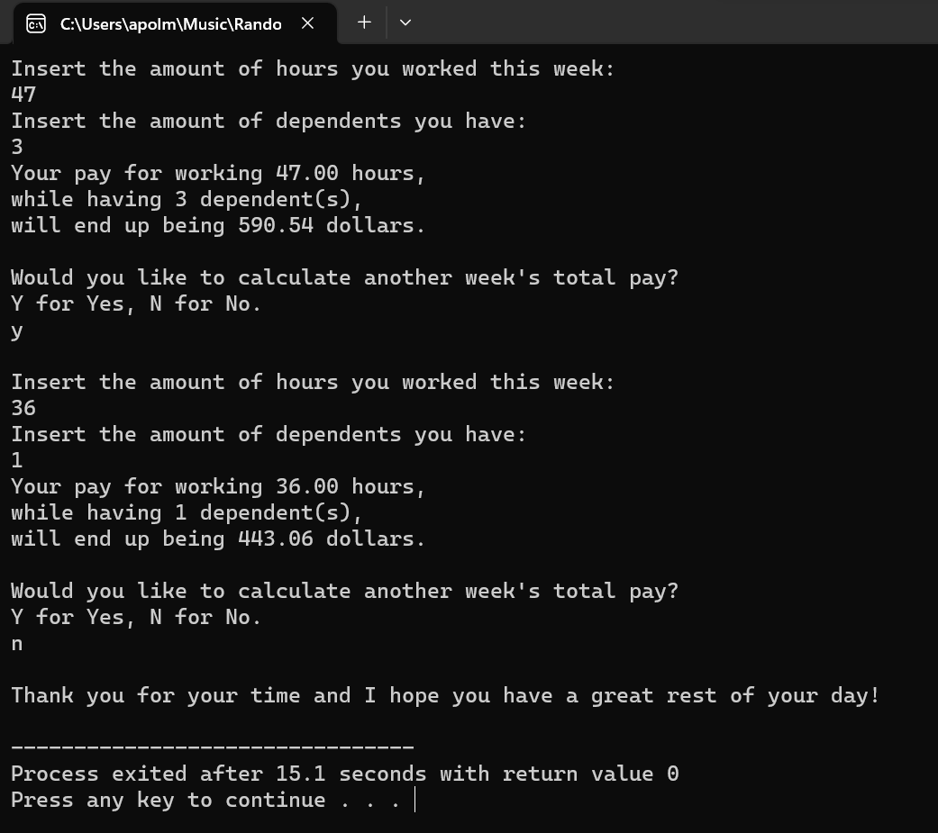

4. Write a program that finds the temperature that is the same in both Celsius and Fahrenheit. The formula to convert from Celsius to Fahrenheit is
Fahrenheit = (9 × Celsius)/ 5 +32
Your program should create two integer variables for the temperature in Celsius and Fahrenheit. Initialize the temperature to 100 degrees Celsius. In a loop, decrement the Celsius value and compute the corresponding temperature in Fahrenheit until the two values are the same.
Since you are working with integer values, the formula may not give an exact result for every possible Celsius temperature. This will not affect your solution to this particular problem.

#include <iostream>
using namespace std;
int main ()
{
int f, c=100;

(f=(9*c)/5 + 32);

while ((f>c)||(c>f))
{
(c--);
(f=(9*c)/5 + 32);
}

cout << "The number where celcius and fahrenheit are equal is " << c << " degress.\n";
return 0;
}

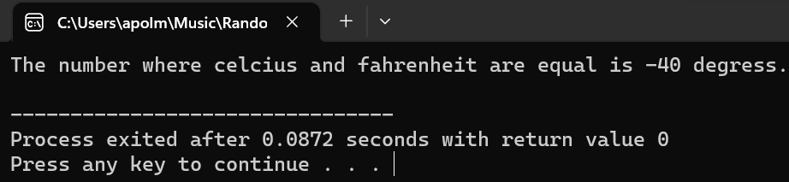

5. Create a program that enter a character and the value of times(v) and print the character v times (please you can use function -no necessary)
#include <iostream>
using namespace std;
int main ()
{
int times;
char letter;

cout << "Please press the return key after you insert your number." << endl
<< "How what character would like repeated?\n";
cin >> letter;
cout << endl;

cout << "Please enter the amount of times you would want it repeated." << endl;
cin >> times;
cout << endl;

for (int t=times;t>0;t--)
{
cout << letter;
}

cout << endl;
return 0;
}
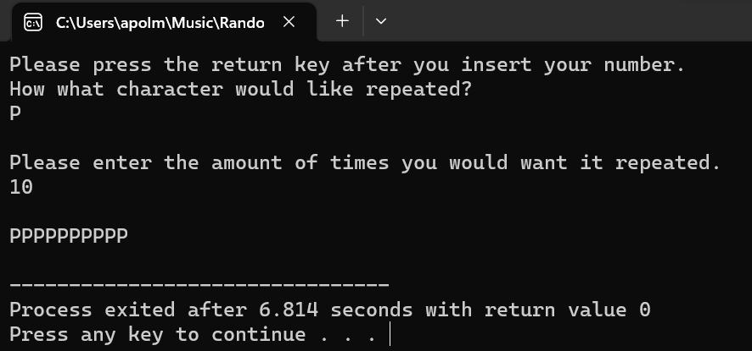

6. Create a program that add positive and negative numbers. If the negative numbers are greater than 2 the program will print the total sum otherwise an analogous message will appear.

#include <iostream>
using namespace std;
int main ()
{
int n_n;
char ans;
double total, n;

cout << "Hello!" << endl
<< "Please enter numbers and this program will add them all up!" << endl
<< "You will need at to input at least 3 negative numbers!" << endl
<< "Enter the number 0 when you want to finally see the sum!" << endl;

do
{
(n_n=0);
(total=0);

do
{
cout << "Enter a number: ";
cin >> n;

if (n < 0)
{
(n_n++);
}

total += n;

} while ((n > 0) || (n < 0));

if (n_n > 2)
{
cout << "Here is the total of all the numbers added up: " << total << endl
<< endl;
}
else
{
cout << "Welp, look like you didn't enter in at least 3 negative numbers" << endl
<< "Looks like you're going to have to try again!" << endl
<< endl;
}

cout << "Would you like to run the program again?" << endl
<< "Y for yes, N for no" << endl;
cin >> ans;
cout << endl;

} while ((ans == 'y')||(ans == 'Y'));

cout << "Thank you for using this program!" << endl
<< "I hope you had a great time!" << endl
<< "Have a great day!" << endl;
return 0;
}

